TECHNICAL PROJECT REPORT

**“Intruder Alarm System”**

# Team Members / Inventors:

|  |  |  |  |  |  |
| --- | --- | --- | --- | --- | --- |
| **S. No.** | **Name** | **Department** | **Designation** | **Mobile** | **E-Mail** |
| 1. | Mudit Sharma | CSE(IBM)  INFO SECURITY | Student | 9501109333 | [mudit.sharma1001@gmail.com](mailto:mudit.sharma1001@gmail.com) |
| 2. | Aditya Bharadwaj | CSE(IBM)  INFO SECURITY | Student | 9592738466 | [bmohit524@gmail.com](mailto:bmohit524@gmail.com) |
| 3. | Divya Garigipati | CSE(IBM)  INFO SECURITY | Student | 9652268078 | [divyanaiduhoney@gmail.com](mailto:divyanaiduhoney@gmail.com) |
| 4. | Khushal Thakur | ECE | Mentor | 9646030764 | [khushal.thakur@cumail.in](mailto:khushal.thakur@cumail.in) |
| 5. | Anshul Sharma | ECE | Mentor | 9478697475 | [anshulsharma.ece@cumail.in](mailto:anshulsharma.ece@cumail.in) |
| 6. | Kiran Jot Singh | ECE | Mentor | 9463909689 | [kiranjotsingh.ece@cumal.in](mailto:kiranjotsingh.ece@cumal.in) |
| 7. | Divneet Singh Kapoor | ECE | Mentor | 9878422653 | [divneet.ece@cumail.in](mailto:divneet.ece@cumail.in) |

Section – 1 (IPR Related)

# Brief Abstract :

We see high-tech security systems in banks but there are not many for general home usage. To come up something like that which could be easily be installed and work well in almost every condition we have developed an intruder alarm system. This system is very much effective for home usage, cost-efficient and reliable. This device can be deployed in lockers, almirahs or at any sensitive corner of home which the user wants to keep ensure remains secure. This system is efficient enough that it can work easily without getting noticed due to its small size.

This work presents a smart trespasser detection and alert system which aims to increase the amount of security as well as the likelihood of positively identifying or stopping trespassers and intruders as compared to other commonly deployed home security system. Using motion sensors, this system can gauge the extent of danger exhibited by a person or animal in or around the home premises, and can forward certain critical information regarding the same to home owners as well as other specified persons such as relevant security authorities. For now, the system simple alerts by triggering a buzzer which can inform the user of the potential threat.

The capabilities of the project can be increased by doing various modifications in the future. To exemplify, GSM module can be used which can send user alert in the form of text message in case he/she is not in the home or the apparatus can be easily linked to the internet connection in home and could be used to trigger alert message designed on the online server in spite of using GSM module. This apparatus could be linked to a specially designed mobile application from which the switching action and other features of the apparatus can be controlled in the real time.

# Existing state-of-the-art and Drawbacks in existing state-of-the-art

|  |  |  |
| --- | --- | --- |
| **S. No.** | **Existing state of art** | **Drawbacks in existing state of art** |
| 1 | US4297684A976  https://patents.google.com/patent/US4297684 | This apparatus works on fibre optics and therefore this would be very much expensive for a domestic use. |
| 2 | US5079538A  https://patents.google.com/patent/US5079538 | This apparatus is specifically designed keeping in mind the necessity of securing automobiles so this could not work very well at domestic usage level. |

# Novel/Additional modifications that you can propose to improve upon drawbacks

* Feature 1

GSM module can be used which can send user alert in the form of text message, or the apparatus can be easily send the alert message triggered by online server from which the apparatus will be connected by internet connection.

* Feature 2

A special mobile application can be designed to control various operations of the apparatus much easily in real time.

# Advantages

* Adv 1

Much more secure than before if the usage of GSM module or online server is incorporated. Now the user can get the notified even if he/she he out of reach of sound from the buzzer.

* Adv 2

Operating the apparatus would become much easier than before if it would be linked to an mobile application.

# Block Diagram

MICRO-CONTROLLER

MOTION SENSOR

BUZZER

Section – 2 (Real Project)

# Materials

|  |  |
| --- | --- |
| COMPONENT | PRICE (Rs) |
| PIR sensor | 170 |
| Arduino UNO | 430 |
| LED | 5 |
| RESISTOR | 5 |
| Buzzer | 35 |
| Battery cap | 15 |
| battery | 15 |
| Connecting wires | 15 |
| Switch | 7 |

# Circuit Diagram

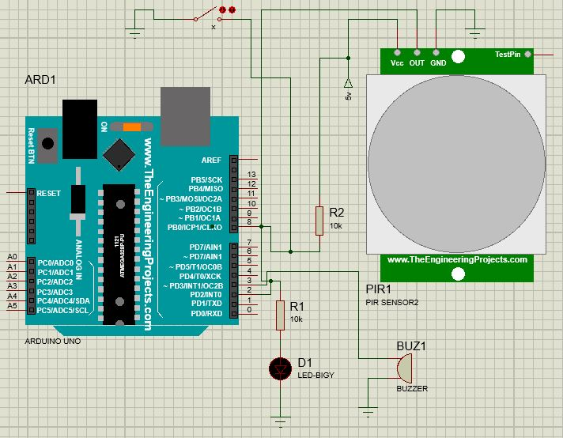

# Steps of Circuit Completion

1. Firstly, link the VCC 5V, OUT, GND of the PIR sensor to the 5V,2nd and GND port on the Arduino Uno.

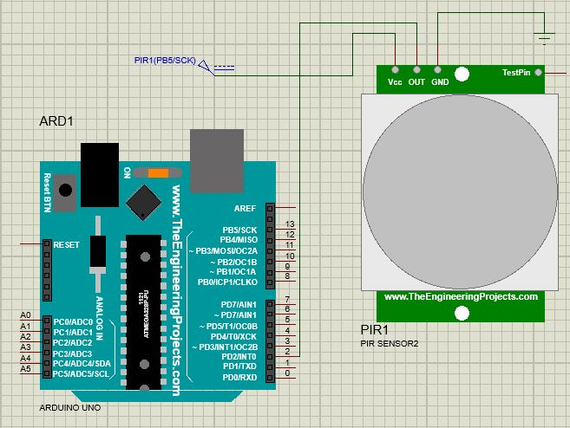

1. Now connect buzzer to 3rd and GND port on Arduino Uno.

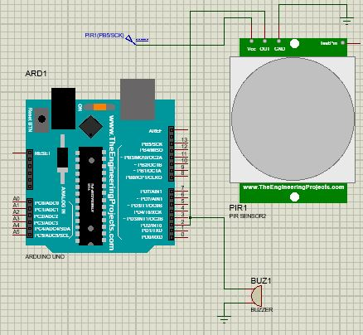

1. Connect one terminal of resistor to the 2nd port on Arduino Uno and another to the LED. Now connect another terminal of LED to the GND.

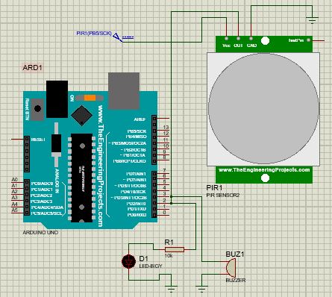

1. Connect one terminal of switch to 5V on Arduino Uno and another to the switch 8th port on Arduino Uno.

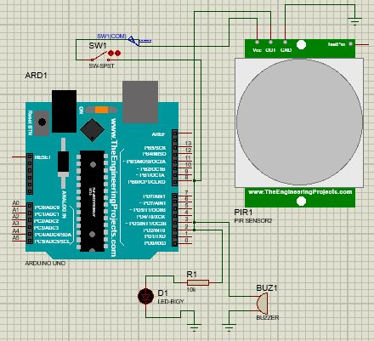

1. Using resistor connect 8th port of Arduino Uno and GND the switch.

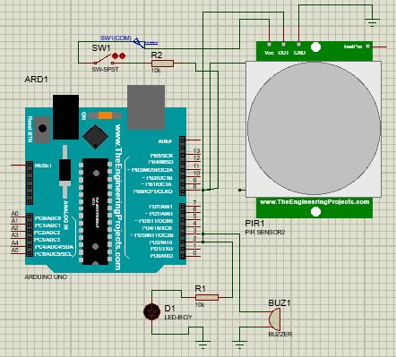

1. At last connect the battery cap to the input terminals of the Arduino Uno (if desired).

Program Code

https://github.com/mudit-khindri/BEEE_course/commit/4ce0a31b11bd012d45527e84695d849be5f2607f